21-DAY EXCEL DATA ANALYTICS CHALLENGE

WEEK 1 – Excel Foundations & Data Familiarity
Focus: Excel interface, formulas, and data basics

Day 1 – Dataset Selection & Import

I have choosed Employee_Details Data Base

I export into Excel – file name Employee_Details

https://github.com/Sumithagithug/Excel-Coding-Challnge/upload

Day 3 – Basic Excel Formulas (Part 1)
Sum()

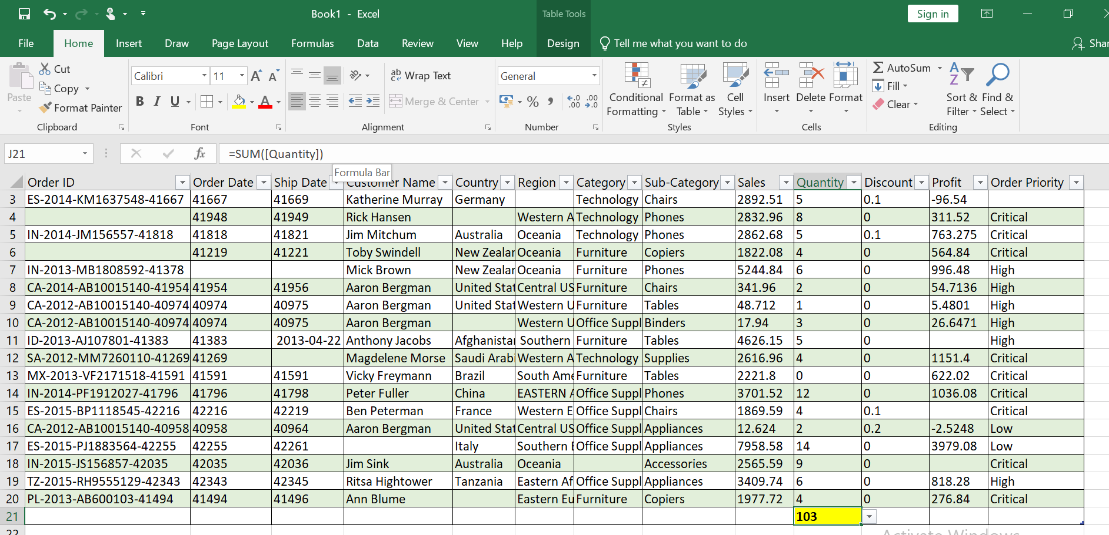

AVERAGE()
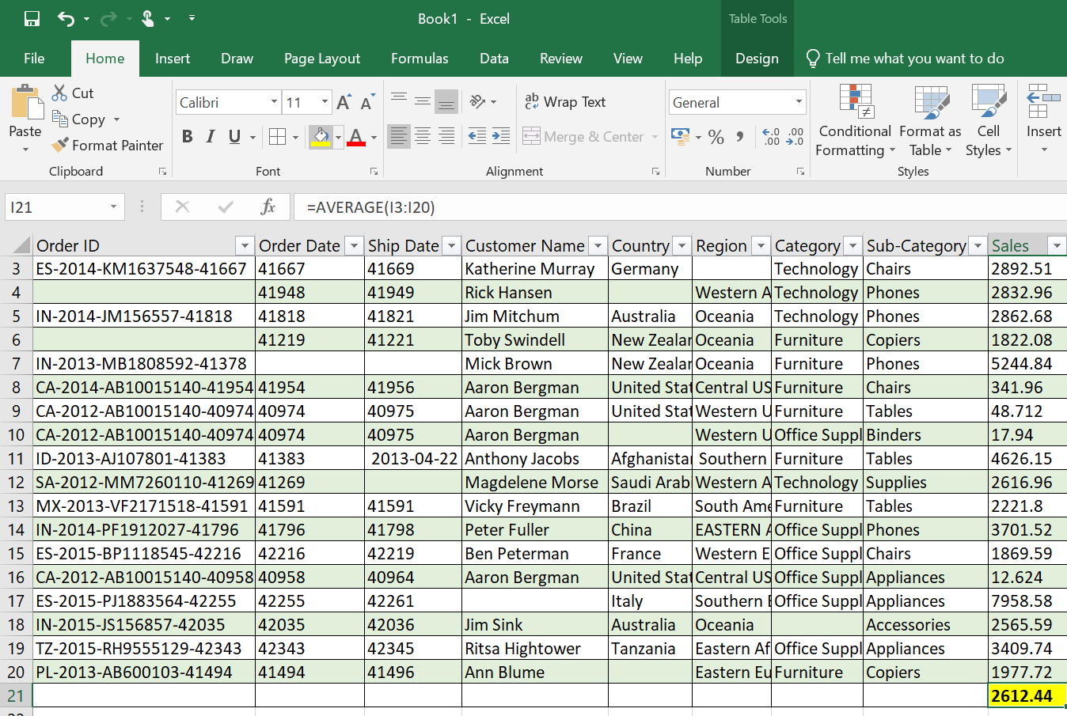

MIN()
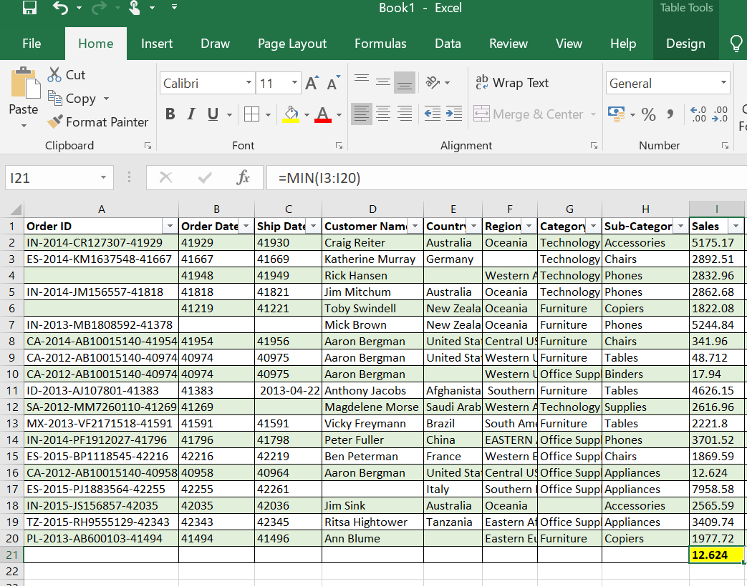
MAX()
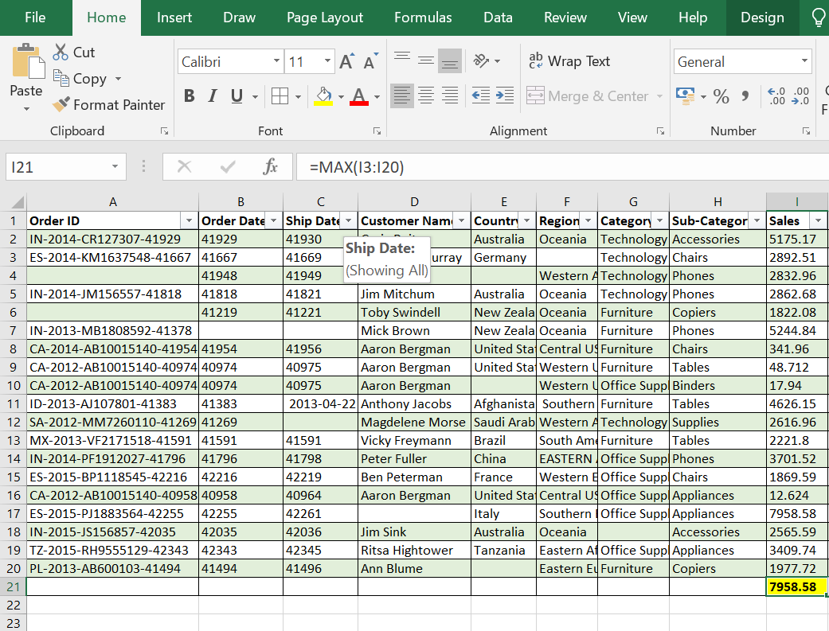
COUNT()
